Statement of Intent for PSHE
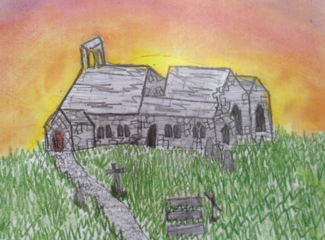
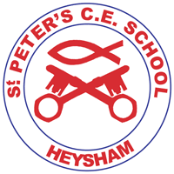
“ I have come in order that you might have life – life in all its fullness,”
John 10:10
Our Vision and Mission
St. Peter’s CE Primary School has been at the heart of the community for over 200 years and continues to play an important role in the lives of children and their families in Heysham. Our vision is to see our children go out into the world with the skills and confidence to succeed and the love, compassion and advocacy to make a positive impact on the world around them.
It is our aim to enable every member of our school family to flourish and live life in all its fullness by:
- Teaching a broad and balanced curriculum
- Holistically nurturing and developing our children
- Helping those in need through loving service
- Confronting injustice in our world
- Caring for creation
In order to achieve this, we will continually ask ourselves:
- What is the source of our fullness?
- What will I be like if I am flourishing?
- What will we be like as a community, and how will we affect those around us, if we are flourishing?

Intent: What do we want children to learn?
At St Peter’s CE Primary School, PSHE is at the core of what we do and enables our children to become independent, confident, healthy and responsible members of society, as well as developing the “whole child” intellectually, morally, socially and spiritually. Through our whole-school approach to PSHE, it is our belief that excellence in these areas will lead to excellence across the curriculum and beyond into later life. PSHE is taught across the school from Early Years to Year 6 on a weekly basis and as a school, we follow the Jigsaw PSHE scheme. Our PSHE curriculum equips children with relevant and meaningful content, which is supported through a strong emphasis on emotional literacy, building resilience and nurturing mental and physical health. With an ever changing society, we are able to provide our children with a strong understanding of the diverse world around them and support them in playing a positive role in contributing to the school and the wider community. Weaving through the heart of our PSHE teaching, is a commitment to enhancing and promoting our core Christian fruits of the Spirit.
Implementation: How do we teach our PSHE Curriculum – what does PSHE look like at St Peter’s?
Our whole curriculum is shaped by our school vision which aims to enable all children to flourish and become the very best version of themselves they can possibly be, making a positive impact on the world around them. We teach the National Curriculum, supported by clear skills and knowledge progression. This ensures that skills and knowledge are built on year by year and sequenced appropriately to maximise learning for all children. Jigsaw PSHE directs our aim on developing the “whole child” through a spiral curriculum approach to developing knowledge, skills and understanding in the areas of;
• Being Me in My World
• Celebrating Difference
• Dreams and Goals
• Healthy Me
• Relationships
• Changing Me
In addition to the discrete lessons taught at St Peter’s CE Primary School, PSHE skills are developed through a number of activities and opportunities such as assemblies, Picture News, visitors, themed weeks, School Council and School Trips.

Impact: How do we know what children have learnt? How do we know learning has ‘stuck’?
The impact of PSHE Curriculum can be seen through the behaviours and attitudes displayed by our pupils within the school and their relationships with others. They will:
- demonstrate kindness and respect towards themselves and others.
- have the courage and ability to try new things, challenge themselves and persevere.
- Take responsibility for their actions.
- have a good understanding of how to stay safe, healthy and how to develop good relationships.
- have an appreciation of what it means to be a positive member of a diverse, multicultural society.
- demonstrate and apply the British Values of Democracy, Tolerance, Mutual Respect, Rule of law and Liberty.
- be equipped to make a positive impact on the world around them
- to be inspired to reach for the stars!

